Now make another setup that supports airflow + Docker + Spark

1. Make sure Docker Desktop + WSL2 integration is set up (on Windows side)
- Install Docker Desktop for Windows if you haven’t already.
- Open Docker Desktop → Settings → General:
  - Make sure “Use the WSL 2 based engine” is checked.
- Go to Settings → Resources → WSL Integration:
  - Turn on integration for your WSL distro (e.g., Ubuntu).
- Make sure Docker is actually running (Docker whale icon in system tray).
You don’t install Docker inside WSL manually; Docker Desktop exposes it into WSL.
3. Create an Airflow project folder (inside WSL)
Pick a directory that’s inside Linux (e.g., under /home/...), not on /mnt/c/... for better performance:
mkdir -p airflow-docker-spark
cd airflow-docker-spark
Note: I decided instead to create in a working directory (not /home/…)
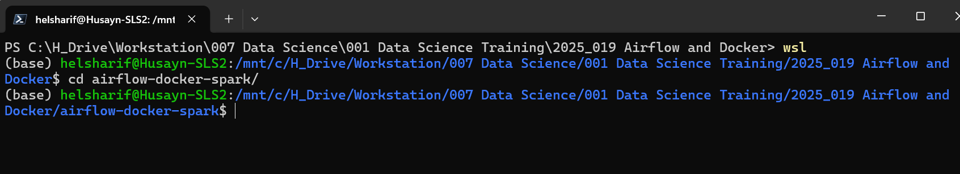
4. Get the official Airflow docker-compose.yaml
I choose latest stable version of airflow (as of 2025-12-30): Version 3.1.5
see: https://airflow.apache.org/docs/apache-airflow/stable/howto/docker-compose/index.html
1. curl -LfO 'https://airflow.apache.org/docs/apache-airflow/3.1.5/docker-compose.yaml'
optional: make the following modifications to the docker-compose.yaml
add tmp folder in volumes:
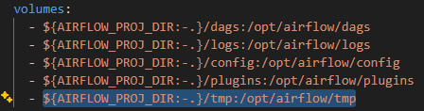
set AIRFLOW__CORE__LOAD_EXAMPLES: ‘false’ so that example dags are not loaded
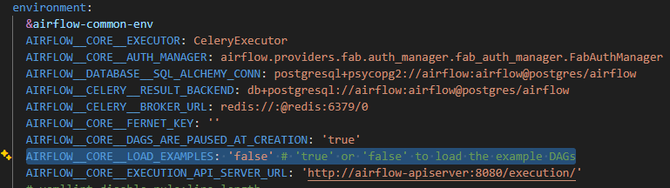
Create a Dockerfile

# Start from official Airflow 3.1.5 image
FROM apache/airflow:3.1.5

# --------------------------
# 1) Install Java 17 (fully supported by Spark 4.1)
# --------------------------
USER root

RUN apt-get update \
&& apt-get install -y --no-install-recommends \
openjdk-17-jre-headless \
&& apt-get autoremove -yqq --purge \
&& apt-get clean \
&& rm -rf /var/lib/apt/lists/*

# Set JAVA_HOME for Java 17
ENV JAVA_HOME=/usr/lib/jvm/java-17-openjdk-amd64
ENV PATH="${JAVA_HOME}/bin:${PATH}"

# --------------------------
# 2) Back to airflow user + install Spark provider + PySpark 4.1
# --------------------------
USER airflow

RUN pip install --no-cache-dir \
"apache-airflow==${AIRFLOW_VERSION}" \
apache-airflow-providers-apache-spark \
"pyspark==4.1.0"

# Keep Airflow version pinned to the core image version
# and add the Spark provider + Spark 4.1 (PySpark)
RUN pip install --no-cache-dir \
"apache-airflow==${AIRFLOW_VERSION}" \
apache-airflow-providers-apache-spark \
"pyspark==4.1.0"

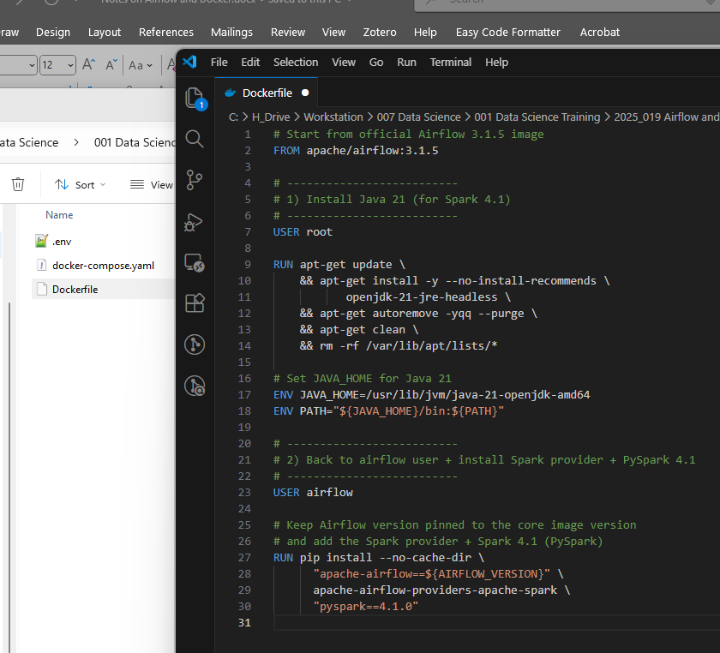

Key points:
- openjdk-21-jre-headless gives you a Java 21 runtime, which Spark 4.1 can use.
- pyspark==4.1.0 pulls in the Spark 4.1 distribution and spark-submit scripts inside the container.
- apache-airflow-providers-apache-spark is what gives you SparkSubmitOperator.
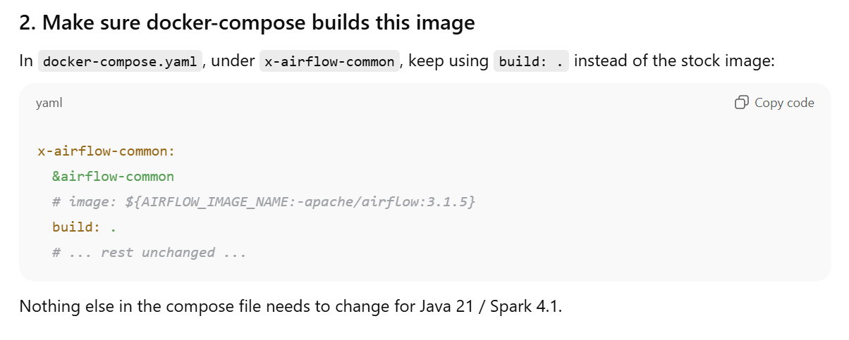
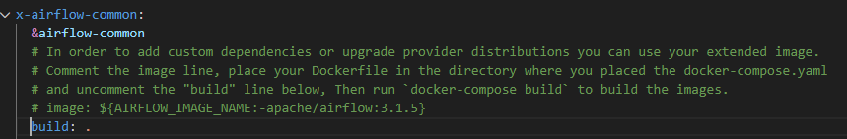

Rebuild and Re-init
docker compose build # rebuild with Java 21 + Spark 4.1
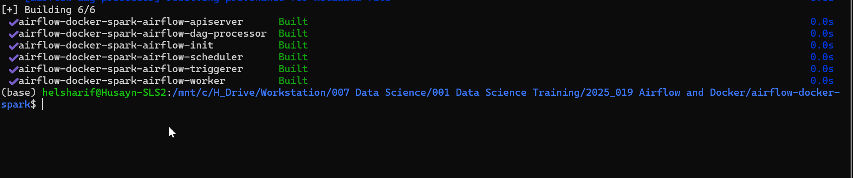
docker compose up airflow-init
docker compose up

If you want a truly fresh Airflow (no old DAGs / metadata)
From your airflow-docker project folder (go to project folder of any suspected running docker airflow projects)
docker compose down --volumes --remove-orphans

Then re-init and start:
docker compose up airflow-init
docker compose up -d
then in a browser go to localhost:8080

Now connecting airflow and spark for a project
From the folder with your docker-compose.yaml
docker compose run --rm airflow-worker \
airflow connections add 'spark_booking' \
--conn-type 'spark' \
--conn-host 'local' \
--conn-extra '{"deploy_mode": "client"}'

That:
- Starts a temporary airflow-worker container using your custom image (with PySpark 4.1 / Java 17).
- Executes the airflow connections add command inside it.
- Persists the connection in the Airflow metadata DB (Postgres), so all services (webserver, scheduler, workers) see spark_booking.
- Then in your DAGs you just reference:
SparkSubmitOperator(
task_id="...",
conn_id="spark_booking",
...
)

Should now appear in Admin > Connections
